**Salt Lake City Downtown Map**

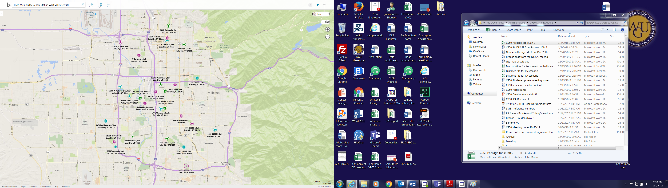

28

27/35

31/32

25/26

6